Test Case Studio – Coverage of a simple two-page web site with JavaScript enabled interactive controls

Methodology
- A simple two-page web site simple JavaScript enabled interactive controls, navigation, and dynamic element update (https://datamakerjs-f3b6b7d13de0.herokuapp.com/)
- Execution of a set of test cases through the web-app based on a simple model of the application functionality
- Record the test cases in Test Case Studio, examine Test Case Studio behavior during recording and compare recorded steps against actual steps
I created a YouTube video showing similar, although not exact, coverage of the test cases in this report. Roughly the same issues were encountered: https://www.youtube.com/watch?v=exOniMaTvPo&t=9s

Example test case:
For the test, I would do the following across every test case I had planned (see test artifacts section below):
- Start Test Case Studio
- Switch to Microsoft Edge
- In a new tab, open DataMaker (datamakerjs-f3b6b7d13de0.herokuapp.com)
- Execute the steps in the table below (see “Step” and “Description” columns)
TC | Test Path | Step | Description | Preconditions | Data | Expected Result | Data | Test Result
1 | 1,4,6,7,17,19,21,11,14,16,28,29 | 1 | Change Namespace (YES)
1 | 1,4,6,7,17,19,21,11,14,16,28,29 | 2 | Change Schema (NO)
1 | 1,4,6,7,17,19,21,11,14,16,28,29 | 3 | Change Number (NO)
1 | 1,4,6,7,17,19,21,11,14,16,28,29 | 4 | Edit (YES)
1 | 1,4,6,7,17,19,21,11,14,16,28,29 | 5 | Modify (YES)
1 | 1,4,6,7,17,19,21,11,14,16,28,29 | 6 | Save (YES)
1 | 1,4,6,7,17,19,21,11,14,16,28,29 | 7 | Back (YES) |  |  |  |  | did not record "Back" command
1 | 1,4,6,7,17,19,21,11,14,16,28,29 | 8 | Change Namespace (YES) |  |  |  |  | Entire browser locks up
1 | 1,4,6,7,17,19,21,11,14,16,28,29 | 9 | Change Schema (NO)
1 | 1,4,6,7,17,19,21,11,14,16,28,29 | 10 | Change Number (NO)
1 | 1,4,6,7,17,19,21,11,14,16,28,29 | 11 | Edit (NO)
1 | 1,4,6,7,17,19,21,11,14,16,28,29 | 12 | Done (YES)

- Examine recorded steps in Test Case Studio for issues and problems.

Issues Discovered
- “Back” button was not consistently recorded going from “Edit” page to main page
- After coming “Back” from “Edit” page, selection of items from either SELECT element would lock and crash the browser
- Names of selection controls and number spinner controls were based on the default selected content in the control (e.g. “5” for the control on the page indicating the number of schema examples to produce) for the step – e.g. “Enter 4 into 5” instead of using the ID which was “#numberofexamples”
- The names of select items kept growing with each case, e.g. in case #1 the schema SELECT element was referred to as “Click on "schemaexamplesbaseobjecttypesnetworktypes"”, but by case #2 it had grown to “Click on "defaultschemadefaultchoiceschemaexamplereferenceschemaexamplesequenceschemaexamplerangealphaschemaex"
- The “Edit” button was in a table cell, and both action of click the button AND clicking just the blank space around the cell where the button was generated a step called “Click on Edit”
- Sometimes clicking the spinner control generated “Double-click on ‘5’” (“5” is the name assigned to the control by Test Case Studio) instead of just recording the change in value. I saw this once doing the following… (starting at five), up, up (records as changing to 6, then 7), down, down, down (should be change to 6, 5, 4,), but the second down generated “double-click on ‘5’” instead. It seemed (?) as if passing back through the original value recorded a double-click, but I might be wrong about that.
The crash on changing either of the SELECT elements after coming hitting the BACK button from the Edit page blocked several of the test cases I intended to cover. I managed to get it to work sometimes by doing an ALT+TAB back and forth between the browser and Excel where I was keeping the test steps, but that did not consistently prevent the crash. I believe the context switching might be relevant – or maybe it is just me slowing down my steps (?)

Test Data and Artifacts
Datamaker repository version used in test: WayneMRoseberry/datatoolsjs at a9cba94c28ddea8cc0d6da7fa991a57159637f1f (github.com)
Test model diagram: https://waynemroseberry.github.io/assets/testcasestudiorecordings/DataMaker%20Edit_Save%20sequence%20two%20times%20depth.png
Test case steps from the model: https://waynemroseberry.github.io/assets/DataMaker_Edit_Save_sequence_two_times_depth_Edge_Coverage.xlsx
Test Case Studio Recordings: https://waynemroseberry.github.io/assets/testcasestudiorecordings
The cases are in the form “allnode_tc_<casenumber>_etc.”. The cases 5 and 7 were blocked because a crash in Test Case Studio lost the session data. Append the file name below to the github address above (e.g. https://waynemroseberry.github.io/assets/testcasestudiorecordings/allnode_tc%20_6_datamakerjs-f3b6b7d13de0-2024-4-17-8-49-9.csv) to see the file
- allnode_tc%20_1_datamakerjs-f3b6b7d13de0-2024-4-17-8-49-9.csv
- allnode_tc%20_1_datamakerjs-f3b6b7d13de0-2024-4-17-8-49-9.zip
- allnode_tc%20_2_datamakerjs-f3b6b7d13de0-2024-4-17-8-49-9.csv
- allnode_tc%20_2_datamakerjs-f3b6b7d13de0-2024-4-17-8-49-9.zip
- allnode_tc%20_3_datamakerjs-f3b6b7d13de0-2024-4-17-8-49-9.csv
- allnode_tc%20_3_datamakerjs-f3b6b7d13de0-2024-4-17-8-49-9.zip
- alnode_tc%20_4_datamakerjs-f3b6b7d13de0-2024-4-17-8-49-9.csv
- alnode_tc%20_4_datamakerjs-f3b6b7d13de0-2024-4-17-8-49-9.zip
- allnode_tc%20_6_datamakerjs-f3b6b7d13de0-2024-4-17-8-49-9.csv
- allnode_tc%20_6_datamakerjs-f3b6b7d13de0-2024-4-17-8-49-9.zip
- allnode_tc%20_8_datamakerjs-f3b6b7d13de0-2024-4-17-8-49-9.csv
- allnode_tc%20_8_datamakerjs-f3b6b7d13de0-2024-4-17-8-49-9.zip

DataMaker UI
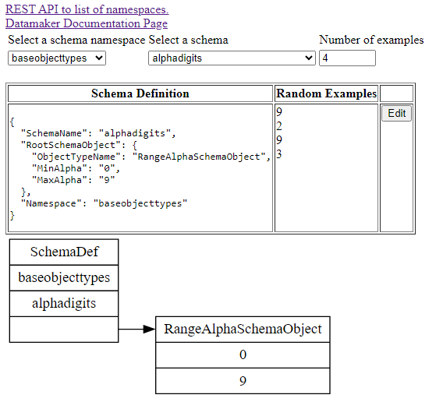
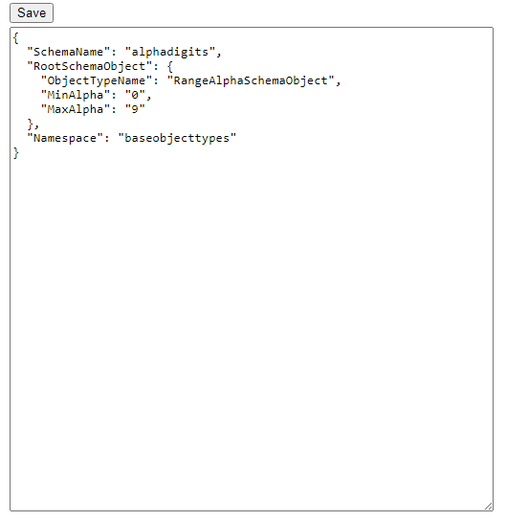

Appendix

HTML of Datamaker Main Page
<body>
<div><a href="../api/namespaces">REST API to list of namespaces.</a></div>
<div><a href="../pages/documentation.html">Datamaker Documentation Page</a></div>
<div>
<span>
<table>
<tbody><tr>
<td>Select a schema namespace</td>
<td>Select a schema</td>
<td>Number of examples</td>
</tr>
<tr>
<td><select id="namespacelist" onchange="loadSchemaDefs(this)" style="outline: none;"><option value="schemaexamples">schemaexamples</option><option value="baseobjecttypes">baseobjecttypes</option><option value="networktypes">networktypes</option></select></td>
<td><select id="schemalist" style="outline: none;"><option value="alphalower">alphalower</option><option value="alphaupper">alphaupper</option><option value="alphadigits">alphadigits</option><option value="numericdigits">numericdigits</option><option value="alphanumericchar">alphanumericchar</option><option value="8charalphanumericstring">8charalphanumericstring</option><option value="initialalpha1to8charstring">initialalpha1to8charstring</option><option value="numeric0to255">numeric0to255</option><option value="copyof8charalphanumericstring">copyof8charalphanumericstring</option><option value="copy2of8charalphanumericstring">copy2of8charalphanumericstring</option><option value="copy3of8charalphanumericstring">copy3of8charalphanumericstring</option><option value="morecopiesnumeric0to255">morecopiesnumeric0to255</option><option value="alphalowerf">alphalowerf</option><option value="aalphalower">aalphalower</option><option value="alphalowwer">alphalowwer</option></select></td>
<td><input id="numberofexamples" type="number" min="1" max="100" value="5" style="outline: none;"></td>
</tr>
</tbody></table>
<br>
<table border="1">
<tbody><tr style="vertical-align:top">
<th>Schema Definition</th>
<th>Random Examples</th>
<th></th>
</tr>
<tr style="vertical-align:top">
<td><div id="schemablob"><pre>{
"SchemaName": "alphadigits",
"RootSchemaObject": {
"ObjectTypeName": "RangeAlphaSchemaObject",
"MinAlpha": "0",
"MaxAlpha": "9"
},
"Namespace": "baseobjecttypes"
}</pre></div></td>
<td><div id="randomexamples"><span id="randexample_0">9</span><br><span id="randexample_1">2</span><br><span id="randexample_2">9</span><br><span id="randexample_3">3</span><br></div></td>
<td><button id="editschemadef" onclick="loadeditschemapage()">Edit</button></td>
</tr>

</tbody></table>
<div id="dotimage"><svg xmlns="http://www.w3.org/2000/svg" xmlns:xlink="http://www.w3.org/1999/xlink" width="316pt" height="158pt" viewBox="0.00 0.00 316.25 157.80">
<g id="graph0" class="graph" transform="scale(1 1) rotate(0) translate(4 153.8)">
<polygon fill="white" stroke="none" points="-4,4 -4,-153.8 312.25,-153.8 312.25,4 -4,4"></polygon>
<!-- def -->
<g id="def" class="node">
<title>def</title>
<polygon fill="none" stroke="black" points="0,-50.1 0,-149.3 104.63,-149.3 104.63,-50.1 0,-50.1"></polygon>
<text text-anchor="middle" x="52.32" y="-132.7" font-family="Times,serif" font-size="14.00">SchemaDef</text>
<polyline fill="none" stroke="black" points="0,-124.5 104.63,-124.5"></polyline>
<text text-anchor="middle" x="52.32" y="-107.9" font-family="Times,serif" font-size="14.00">baseobjecttypes</text>
<polyline fill="none" stroke="black" points="0,-99.7 104.63,-99.7"></polyline>
<text text-anchor="middle" x="52.32" y="-83.1" font-family="Times,serif" font-size="14.00">alphadigits</text>
<polyline fill="none" stroke="black" points="0,-74.9 104.63,-74.9"></polyline>
<text text-anchor="middle" x="52.32" y="-58.3" font-family="Times,serif" font-size="14.00"> </text>
</g>
<!-- def_ra1 -->
<g id="def_ra1" class="node">
<title>def_ra1</title>
<polygon fill="none" stroke="black" points="140.63,-0.5 140.63,-74.9 308.25,-74.9 308.25,-0.5 140.63,-0.5"></polygon>
<text text-anchor="middle" x="224.44" y="-58.3" font-family="Times,serif" font-size="14.00">RangeAlphaSchemaObject</text>
<polyline fill="none" stroke="black" points="140.63,-50.1 308.25,-50.1"></polyline>
<text text-anchor="middle" x="224.44" y="-33.5" font-family="Times,serif" font-size="14.00">0</text>
<polyline fill="none" stroke="black" points="140.63,-25.3 308.25,-25.3"></polyline>
<text text-anchor="middle" x="224.44" y="-8.7" font-family="Times,serif" font-size="14.00">9</text>
</g>
<!-- def&#45;&gt;def_ra1 -->
<g id="def.def_ra1" class="edge">
<title>def:F1-&gt;def_ra1:F0</title>
<path fill="none" stroke="black" d="M104.63,-62.7C116.01,-62.7 121.32,-62.7 129.19,-62.7"></path>
<polygon fill="black" stroke="black" points="129.12,-66.2 139.12,-62.7 129.12,-59.2 129.12,-66.2"></polygon>
</g>
</g>
</svg></div>

</span>
</div>

<script async="" type="text/javascript" src="https://cdn.testrigor.com/actions-recorder.min.js"></script><script src="../pages/mainindex.js"></script>
<script src="../pages/vizjswrapper.js"></script>
<script>
!function(e, t, n, o) {
if (!window.Promise) return void (e[t] = e[t] || function() {
});
e[t] = e[t] || function() {
var n = arguments;
return new Promise(function(o, r) {
(e[t].q = e[t].q || []).push({ a: n, d: { y: o, n: r } })
})
};
var r = document.createElement(n), a = document.getElementsByTagName(n)[0];
r.async = !0, r.type = "text/javascript", r.src = "https://cdn.testrigor.com/actions-recorder.min.js", r.onload = r.onreadystatechange = function() {
this.readyState && "complete" !== this.readyState || new Recorder.init({ token: "2e880226-baa8-4f1f-996e-3e426cb8a00b", saveAllData: "true" })
}, a.parentNode.insertBefore(r, a)
}(window, "Recorder", "script");
</script>
</body>

HTML of Edit Page body
<body>
<table>
<tbody><tr><td><button type="button" onclick="saveSchemaDef()">Save</button></td></tr>
<tr><td><textarea id="schemadefjson" style="width: 500px; height: 500px"></textarea></td></tr>
</tbody></table>
<script src="editschema.js"></script>

</body>

